Chapter 10, Problem 75.

In the op amp circuit of Fig. 10.118, find the closed-loop gain and phase shift of the output voltage with respect to the input voltage if C₁ = C₂ = 1 nF, R₁ = R₂ = 100 kΩ, R₃ = 20 kΩ, R₄ = 40 kΩ, and
ω = 2000 rad/s.

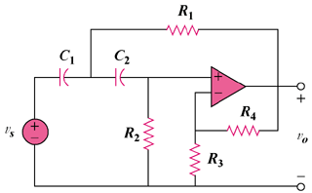

Figure 10.118
For Prob. 10.75.

